**KAMPALA URBAN SCHOOLS**

**BEGINNING OF FEBRUARY EXAMINATIONS, 2024**

**PRIMARY SIX INTEGRATED SCIENCE**

**NAME:________________________________________STREAM: _______**

**SECTION A (40MKS**

1. Mention any one substance that can float on water.

…………………………………………………………………………………………………………………………………..

1. Which animal management is carried out using a burdizzo?

………………………………………..…………………………………………………………………………………………

1. Write any one example of common fuels in Uganda.

…………………………………………………………………………………………………………………………………..

1. Why do worker bees collect nectar from flowers?

…………………………………………………………………………………………………………………………………..

1. Give a reason why pregnant women need carbohydrates.

…………………………………………………………………………………………………………………………………..

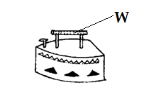**The diagram below shows a common household item. Use it to answer the question that follows.**

1. Name any one substance that can be used to make part W.

………………………………………………………………………………………………………………………………….

1. Name the viral immunisable disease that affects skeletal system.

………………………………………………………………………………………………………………………………….

1. Mention one component of biological environment.

………………………………………………………………………………………………………………………………….

1. Besides boiling, how else can water be made safe for drinking?

…………………………………………………………………………………………………………………………………

1. Which method of heat transfer makes water to boil in a kettle?

…………………………………………………………………………………………………………………………………….

1. What type of change occurs when firewood is burnt to ashes?

…………………………………………………………………………………………………………………………………….

1. Write down one insect which undergoes complete metamorphosis.

…………………………………………………………………………………………………………………………………….

1. Name the product obtained after shearing sheep.

…………………………………………………………………………………………………………………………………….

1. Why do people in rural areas prefer rearing poultry using free-range system?

……………………………………………………………………………………………………………………………………..

1. What happens to digested food in the ileum of a person?

……………………………………………………………………………………………………………………………………..

1. State the importance of tendrils to a passion fruit plant.

………………………………………………………………………………………………………………………………………

1. Give any one reason why poultry farmers debeak their birds.

……………………………………………………………………………………………………………………………………..

The diagram below shows how soil erosion is controlled. Use it to answer the question that follows.

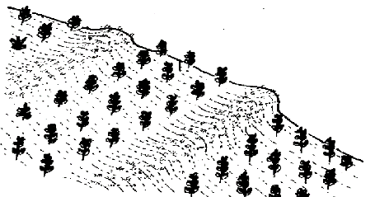

1. Which kind of farming area needs the methods shown above?

……….…………………………………………………………………………………………………………………………….

1. Why is breast milk more recommended to a baby than cow milk?

……………………………………………………………………………………………………………………………………..

1. Apart from a breast-feeding baby, mention one vulnerable people.

………………………………………………………………………………………………………….………………………….

1. State any one method of controlling crop pests in root crop gardens.

……………………………………………………………………………………………………………………………………..

1. Which element of primary health care prevents kwashiorkor in children?

…………………………………………………………………………………………………………………………………….

1. Explain the importance of waste bins found in the school compound.

…………………………………………………………………………………………………………………………………….

1. In which way is rusting and burning similar?

………………………………………………………………………………….………………………………………………….

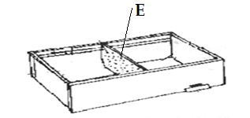The diagram below shows a beehive. Use it to answer the questions that follow.

1. Name the structure marked E.

……………………………………………………………………………………………………………………………………..

1. Give any one advantage of the beehive above over a woven type.

……………………………………………………………………………..…………………………………………………….

1. Outline any one way of controlling African swine fever in a farm.

……………………..…………………………………………………………………………………………………………….

1. Which state of matter expands the most when heated?

…………………….……………………………………………………………………………………………………………..

1. Why do some plants shed off their leaves in dry season?

…………………………………………………………………………………………………………………………………..

1. State any one reason why goat farmers castrate most of theirgoats.

……………….………………………………………………………………………………………………………………….

1. What special name is given to the first milk produced by a mother after giving birth?

…………..………………………………………………………………………………………………………………………

1. What percentage does oxygen take up in air?

…………….………………………………………………………………………………………………………………..……

1. Name the type of soil which has the highest capillarity.

…………………..…………………………………………………………………………………………………….…………

1. Give any one difference between a maize grain and a bean seed.

……………………………………………………………………………………………………………………………………

………….………………..………………………………………………………………………………………………………

1. Of what importance is saliva secreted in your mouth?

……………….……………………………………………………………………………………………………………….…

1. Give any one effect of heat on matter.

……………………………………………………………………………………………………………………………..……

1. Which part of a bird’s digestive system contains grit?

……………………………………………………………………………………………………………………………..……

1. How are the breasts of a mother useful to her newly born baby?

……………………………………………………………………………………………………………………………………

The diagram below shows root crops. Use it to answer question 39.

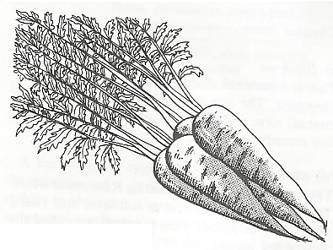

1. Name the root crops shown above.

………………………………………………………………………………………………………………………………..…

1. Why do garbage collectors wear gumboots and gloves?

…………..……………………………………………………………………………………………………………………..

***SECTION B***

1. a) Which form of energy makes water to turn into steam?

………………………………………………………………………………………………………………………………….

b) Name the processes described in the following cases below

* + 1. Steam turning to water ……………………………………………………………………………………
    2. Water turning into ice ……………………………………………………………………………………

c) Why is turning of water into ice called a physical change?

………………………………………………………………………………………………………………………………….

1. a) State any two conditions needed to make iron to rust.
   * 1. …………..……………………………………………………………………………………………………………….
     2. …………….……………………………………………………………………………………………………………..

b) Give any one disadvantage of rusting.

…………..………………………………………………………………………………………………………………………..

c) Apart from rusting, name one other chemical change.

…………..……………………………………………………………………………………………………………………….

1. a) Write any two ways of caring for piglets.
   * 1. ………………………………………………………………………………………………………………………………….
     2. ………………………………………………………………………………………………………………………………….

b) Give any two reasons why people rear animals like goats.

i) …..……………………………………………………………………………………………………………………………

ii) …………………………………………………………………………………………………………………..…………..

1. a) Where in your body does digestion of food begin and end?
   * 1. Begin………………………………………………………………………………………………………………..

ii) End………………………………………………………………………………………………………………….

b) Name any one class of food that is not digested in the body.

………….…………………………………………………………………………………………………………………………

c) Give any one water borne disease of the digestive system. ………….………………………………………………………………………………………………………………….………

1. a) Mention one example of fungi.

…………..…………………………………………………………………………………………………………..…………..

b) How do fungi reproduce?

…………..……………………………………………………………………………………………………………………….

c) State the difference between gills of a mushroom and those of a tilapia.

………………………………………………………………………………………………………………………………...……..………………………………………………………………………………………………………………………………….

c) Mention any one example of a fungal disease in people.

……………………………………………………………………………………………………………………………………

1. **Complete the table below by filling in the missing information correctly**.

|  |  |  |
| --- | --- | --- |
| **Immunisable disease** | **Age of vaccination** | **Site where vaccine is given** |
| a)………………………………….. | At birth | mouth |
| Pertussis | 6 weeks | b)……………………………………… |
| Tuberculosis | c) ………………………. | Right upper arm |
| d) ………………………………… | At 9 months | Left upper arm |

1. a) What name is given to the house of reared rabbits?

………………………………………………………………………………………………………………………………….

b) Give two exotic breeds of rabbits

* + 1. ………………………………………………………………………………………………………………………….
    2. …………………………………………………………………………………………………………………………..

c) Which disease of rabbits also kills chickens in large numbers?

……………………………………………………………………………………………………………………………………

1. The diagram below shows how layers of soil are arranged. Use it to answer the questions that follow.

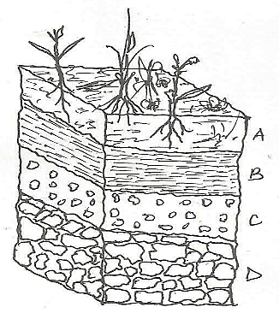

* + - 1. What special name is given to the arrangement of soil layers shown above?

…………………………………………………………………………………………………………………………………..

* + - 1. Name the best layer for growing crops.

…………………………………………………………………………………………………………………………………

* + - 1. Give any two components of soil.

1. ………………………………………………………………………………………………………………………
2. ………………………………………………………………………………………………………………………
3. a) What is the meaning of the term vices in poultry keeping?

……………………………………………………………………………………………………………………………….

b) Which vice makes farmers who keep layers get losses?

………………………………………………………………………………………………………………………………….

c) Give any two ways farmers who keep layers control the vice named in (b) above

* + 1. …..……………………………………………………………………………………………………………………..

ii) …………………………………………………………………………………………………………………………

1. **The diagram shows a method used in measurement. Use it to answer the questions that follow.**

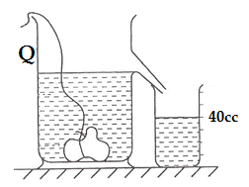

1. Name the container marked Q.

…………………………………………………………………………………………………………………………..………

1. Identify the method used for measuring volume shown above.

………………………………………………………………………………………………………………………………..…

1. What is the volume of the object tied to the string?

……………………………………………………………………………………………………………………………………

1. Calculate the mass of the object on the string if its density is 6g/cc (given that Mass = density × volume).
2. a) What is weather?

…………………………………………………………………………………………………………………………………….

…….…………………………………………………………….…………………………………………………………….…

b) Name the element of weather that enables farmers to dry their harvested crops.

……….…………………………………………………………………………………………………………………………

c)Write down any two disasters due to too much rainfall.

* + 1. …………………………………………………………………………………………………………………………
    2. …………………………………………………………………………………………………………………………

1. a) Give two products got from bees.
2. ………………………………………………………………………………………………………………………….
3. …………………………………………………………………………………………………………………………..

b) Why do bees sometimes abscond from their hives in an apiary?

……………………………………………………………………………………………………………………………………

c) Give any one way beekeepers prevent their bees from swarming.

…………………………………………………………………………………………………………………………………..

1. a) Mention any two elements of primary health care.
   * 1. ………………………………………………………………………………………………………………………….
     2. ………………………………………………………………………………………………………………………….

b) State any one example of good lifestyles that promote health.

………………………………………………………………………………………………………………………………….

c) In which way is a school health committee useful at school?

…………………………………………………………………………………………………………………………………

………………………………………………………………………………………………………………………………….

1. a) Give any a reason why pregnant women are called vulnerable people.

………………………………………………………………………………………………………….………………………..

b) Give any two ways of caring for a pregnant woman to keep her healthy.

* + 1. …………………………………………………………………………………………………………………………..
    2. …………………………………………………………………………………………………………………………..

c) Mention the class of food that promotes rapid growth of the unborn baby in a pregnant woman.

…………………………………………………………………………………………………………………….................

1. The diagram below shows how a mother prepared some special fluid for her sick daughter. Use it to answer the questions that follow.

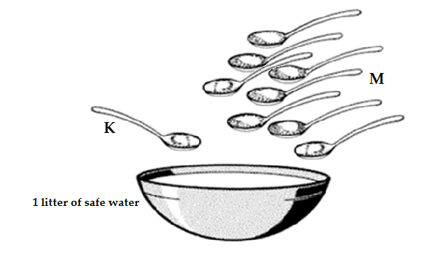

a) What did the mother make for her sick daughter?

……………………………………………………………………………………………………………………………..……

b) Name the substance marked with letters K and M

K…………………………………………………………………………………………………………………………..……

M……………………………………………………………………………………………………………………………….

c) Give a reason why the mother included substance M in what she made.

………………………………………………………………………………………………………………………………….